Using Code::Blocks 10

# First Run

When Code::Blocks is first run it will look for compilers to configure. Assuming you have gcc installed (MinGW can be installed from the same package if using Windows) the window should look like this. This is correct.

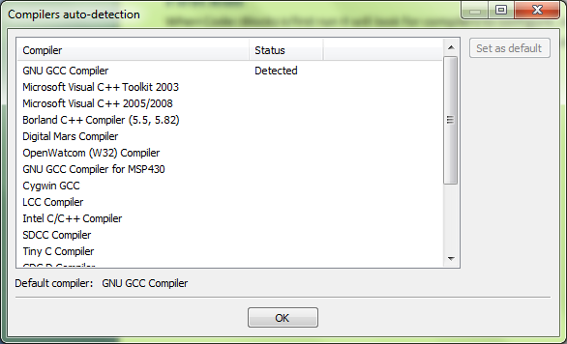

If you do not have another, preferred IDE then allow it to associate itself with C files.

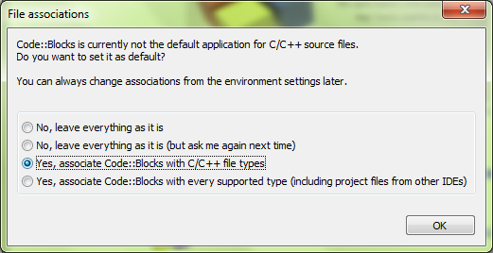

The “Tip of the Day” and the “Scripting Console” can be closed.

# Creating a C Project

1. Select “File->New->Project”:

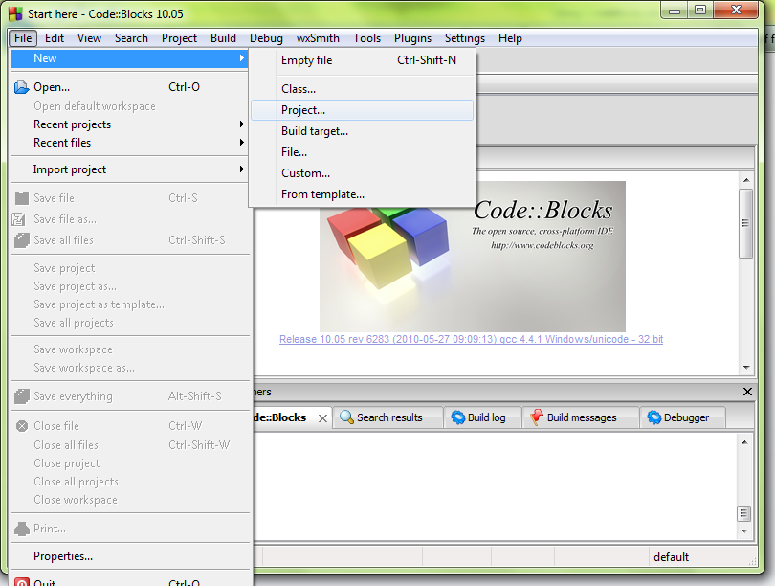

1. Select Console Application and then Go.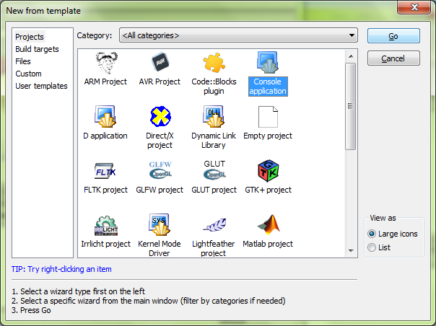
2. Select C:

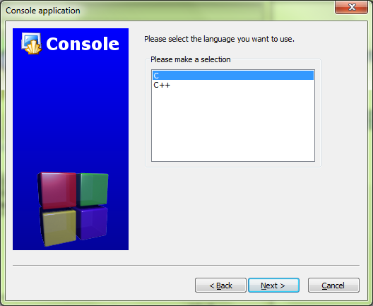

1. Fill in a title and parent folder. The defaults for the file name and resulting path can usually be left.

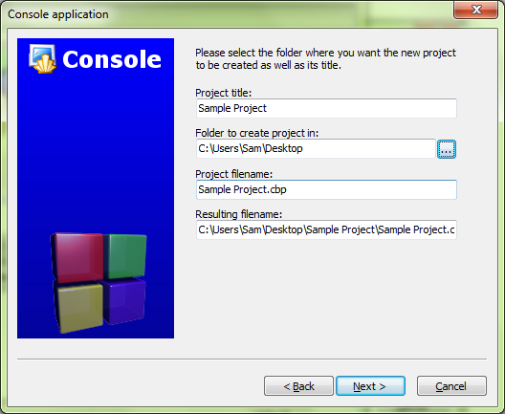

1. The defaults on the next screen can be kept:

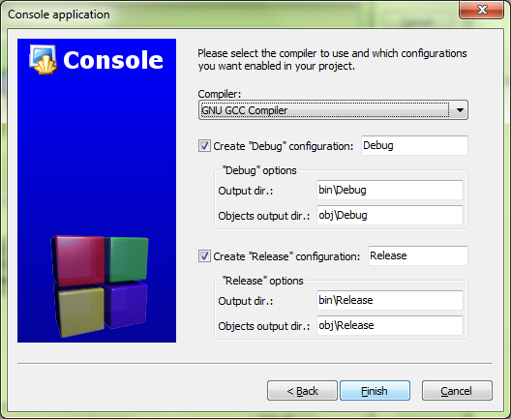

1. Find main.c from the Manager pane on the left to open the default C files

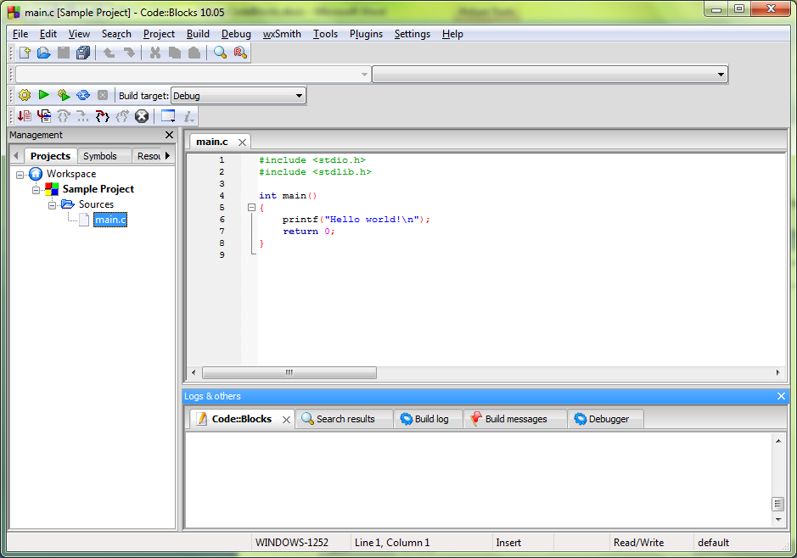

1. Press F9 or click the circled button to build and run your project.

